LEVEL-2

TASK-2

PRICE RANGE ANALYSIS

CODE

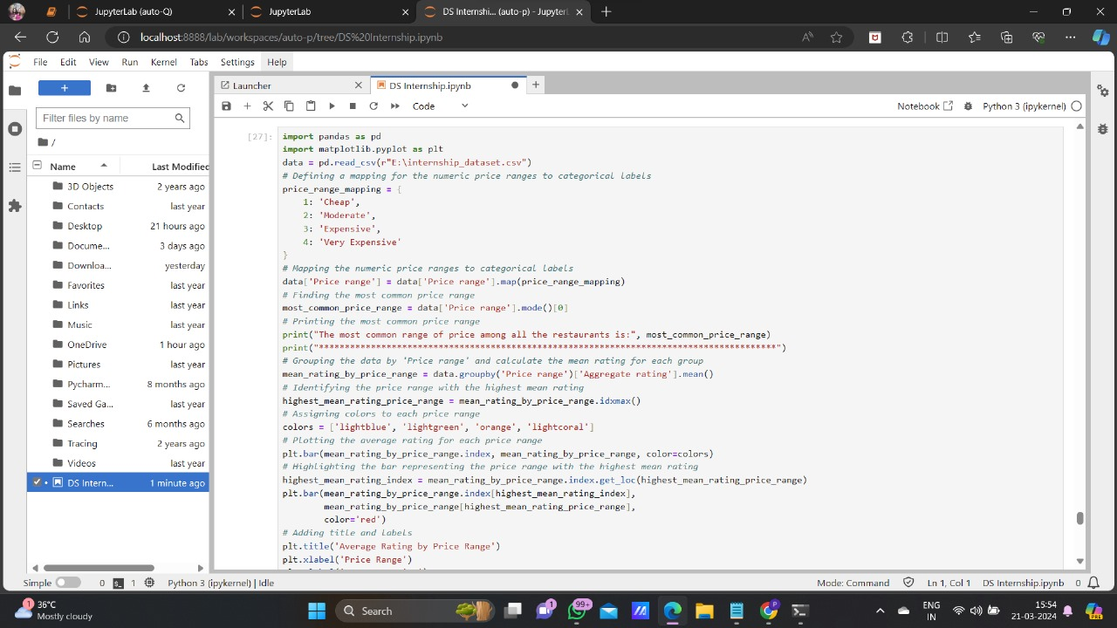

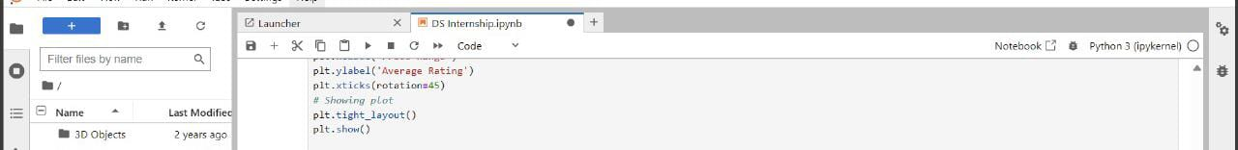

OUTPUT

